ER Model

The Entity-Relationship Model (ER Model) is a conceptual model for designing a database. This model represents the logical structure of a database, including entities, their attributes, and relationships between them.
- Entity: An object that is stored as data. E.g: Student, Course, or Company.
- Attribute: Properties that describe an entity. E.g: StudentID, CourseName, or EmployeeEmail.
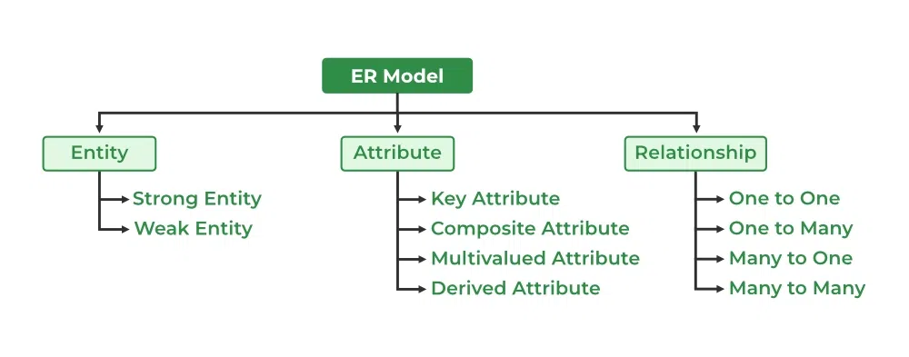
- Relationship: A connection between entities. E.g: Student enrolls in a Course.
Components of ER Diagram
The graphical representation of this model is called an Entity-Relation Diagram (ERD).

ER Model in Database Design Process
We typically follow the below steps for designing a database for an application.
- Gather the requirements (functional and data) by asking questions to the database users.
- Create a logical or conceptual design of the database. This is where ER model plays a role. It is the most used graphical representation of the conceptual design of a database.
- After this, focus on physical database design (like indexing) and external design (like views).

Uses of ER Diagrams in DBMS
- ER diagrams represent the E-R model in a database, making them easy to convert into relations (tables).
- These diagrams serve the purpose of real-world modeling of objects which makes them intently useful.
- Unlike technical schemas, ER diagrams require no technical knowledge of the underlying DBMS used.
- They visually model data and its relationships, making complex systems easier to understand.

Symbols Used in ER Model
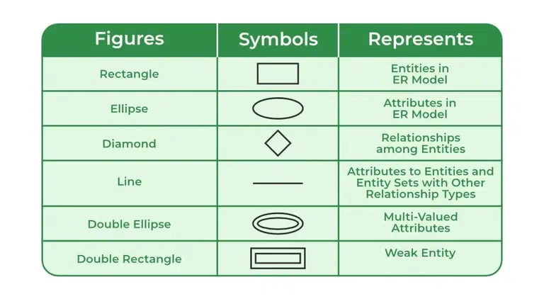
ER Model is used to model the logical view of the system from a data perspective which consists of these symbols:

Symbols used in ER Diagram

Entity
It represents a real-world object, concept or thing about which data is stored in a database. It act as a building block of a database. Tables in relational database represent these entities.
Example of entities:
- Real-World Objects: Person, Car, Employee etc.
- Concepts: Course, Event, Reservation etc.
- Things: Product, Document, Device etc.
The entity type defines the structure of an entity, while individual instances of that type represent specific entities.

Types of Entity
There are two main types of entities:

1. Strong Entity
A type of entity that has a key Attribute that can uniquely identify each instance of the entity. A Strong Entity does not depend on any other Entity in the Schema for its identification. It has a primary key that ensures its uniqueness and is represented by a rectangle in an ER diagram.

2. Weak Entity
It cannot be uniquely identified by its own attributes alone. It depends on a strong entity to be identified. A weak entity is associated with an identifying entity (strong entity), which helps in its identification. A weak entity are represented by a double rectangle. The participation of weak entity types is always total. The relationship between the weak entity type and its identifying strong entity type is called identifying relationship and it is represented by a double diamond.
Example:
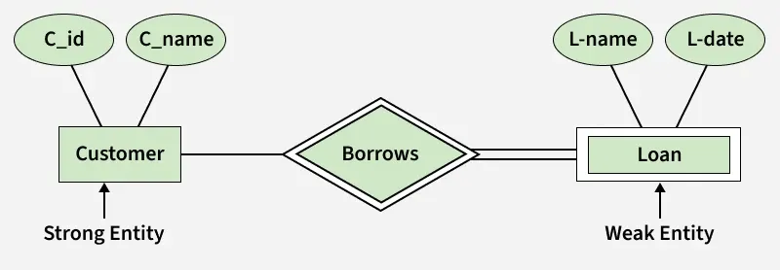
A company may store the information of dependents (Parents, Children, Spouse) of an Employee. But the dependents can't exist without the employee. So dependent will be a Weak Entity Type and Employee will be identifying entity type for dependent, which means it is Strong Entity Type.
Strong Entity and Weak Entity

Entity Set
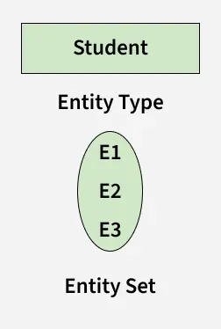
Refers to an individual object of an entity type, and the collection of all entities of a particular type is called an entity set. For example, E1 is an entity that belongs to the entity type "Student," and the group of all students forms the entity set.
Entity Set
We can represent the entity sets in an ER Diagram but we can't represent individual entities because an entity is like a row in a table,


